**ĐẠI HỌC QUỐC GIA TP.HCM**

TRƯỜNG ĐẠI HỌC CÔNG NGHỆ THÔNG TIN



**OFF-CLASS LABS REPORT**

**CLASS: NT219.P21.ANTT**

**Giảng viên hướng dẫn – TS. Nguyễn Ngọc Tự**

**Sinh viên thực hiện:**

**23520669 – Phạm Lê Đăng Kha**

Mục lục

1. HARDWARE RESOURCE 3

2. Lab 1: Coding DES, AES using Cryptopp Library 3

2.1. BUILD TASKS 3

2.1.1. DES 3

2.1.2. AES 4

2.2. Computation Performance 5

2.2.1. DES 5

2.2.2. AES 7

2.3. Comparision And Comments 10

3. Lab 2: Coding AES using only C++ without other cryptographic external libraries 12

3.1. Build Tasks 12

3.1.1. AES CLI 12

3.1.2. AES From Screen 12

3.1.3. AES GUI 13

3.2. Computation Performance 14

3.3. Comparision and Comments 16

4. Lab 3: RSA-OAEP Cipher using CryptoPP 16

4.1. Build task 16

4.1.1. RSA CLI 16

4.1.2. RSA GUI 18

4.2. Computation Performance 20

4.3. Comparison and Comments 20

# HARDWARE RESOURCE

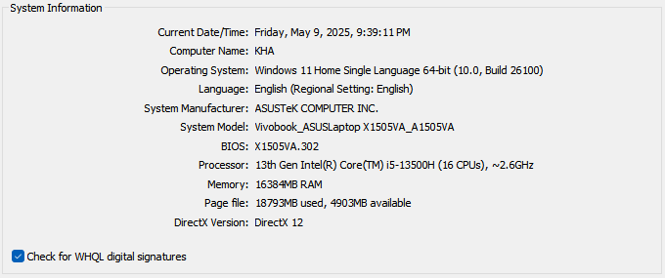

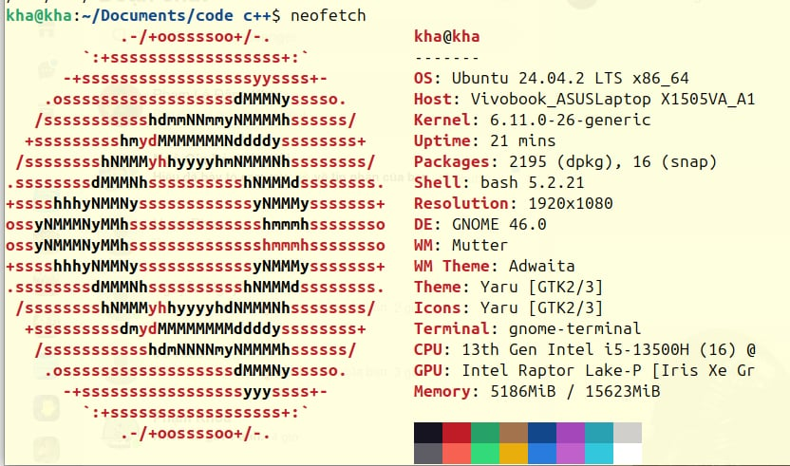

# Lab 1: Coding DES, AES using Cryptopp Library

## BUILD TASKS

### DES

Command line

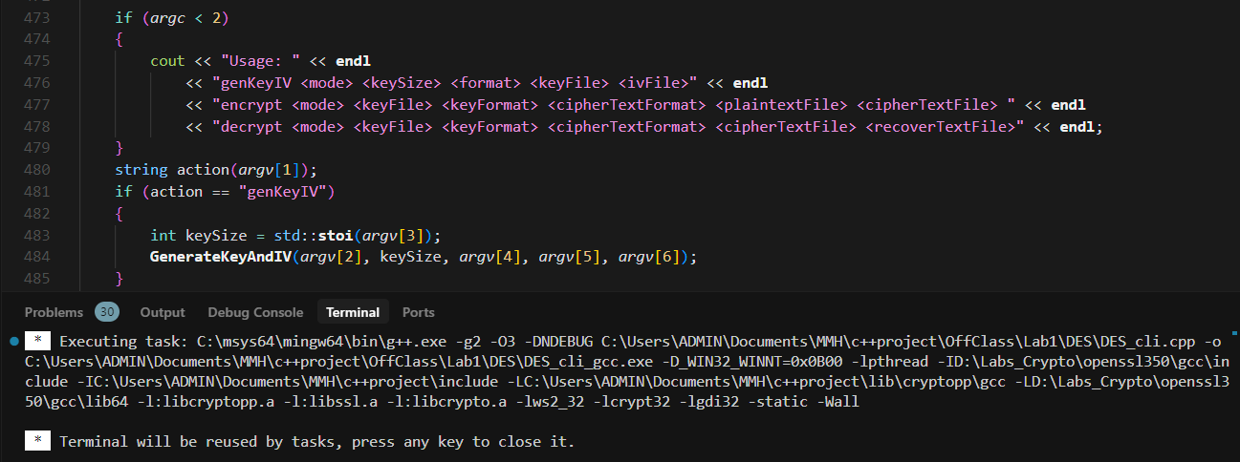

GUI

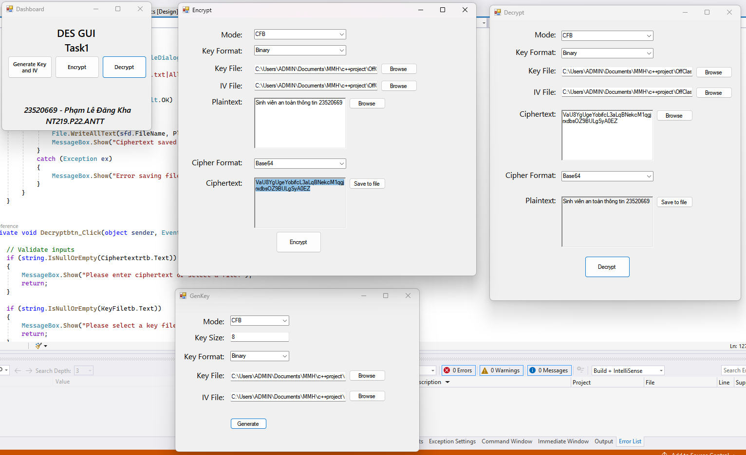

### AES

Command line

* Windows:

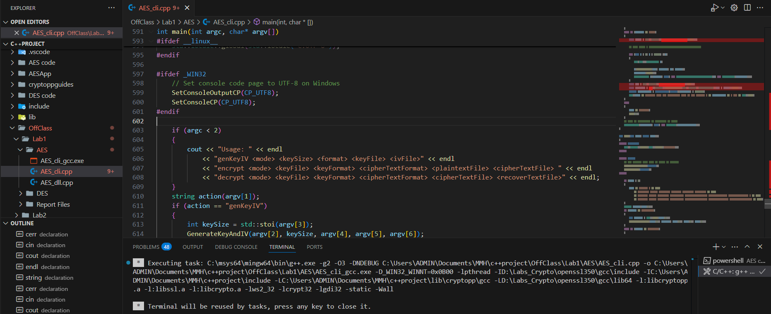

* Ubuntu:

GUI

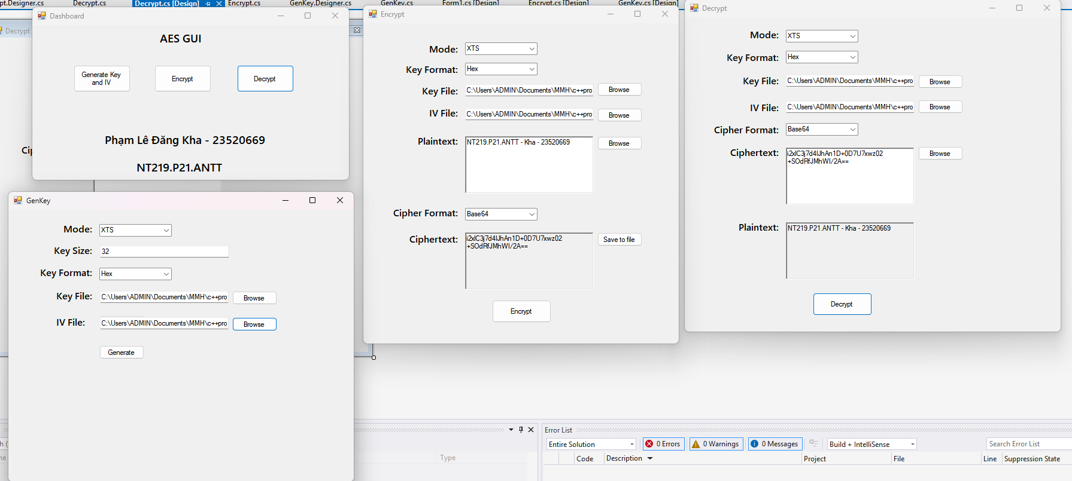

## Computation Performance

Number of iterations: 10000

Time counter: miliseconds (ms)

### DES

Testcase 1 (1KB):

|  |  |  |  |  |
| --- | --- | --- | --- | --- |
| Mode | Encrypt (Windows) | Decrypt (Windows) | Encrypt (Ubuntu) | Decrypt (Ubuntu) |
| ECB | 0.0097 | 0.0082 | 0.008 | 0.0078 |
| CBC | 0.0091 | 0.0088 | 0.009 | 0.008 |
| CFB | 0.0091 | 0.0083 | 0.0089 | 0.0089 |
| OFB | 0.0095 | 0.0093 | 0.0089 | 0.0078 |
| CTR | 0.01 | 0.0098 | 0.0094 | 0.0093 |

Test case 2 (30KB):

|  |  |  |  |  |
| --- | --- | --- | --- | --- |
| Mode | Encrypt (Windows) | Decrypt (Windows) | Encrypt (Ubuntu) | Decrypt (Ubuntu) |
| ECB | 0.2345 | 0.2363 | 0.2247 | 0.2278 |
| CBC | 0.2611 | 0.236 | 0.2583 | 0.2286 |
| CFB | 0.2605 | 0.248 | 0.2559 | 0.2558 |
| OFB | 0.265 | 0.2614 | 0.2549 | 0.2298 |
| CTR | 0.2776 | 0.2909 | 0.2691 | 0.2694 |

Test case 3 (50KB):

|  |  |  |  |  |
| --- | --- | --- | --- | --- |
| Mode | Encrypt (Windows) | Decrypt (Windows) | Encrypt (Ubuntu) | Decrypt (Ubuntu) |
| ECB | 0.3814 | 0.4128 | 0.3733 | 0.3728 |
| CBC | 0.4364 | 0.4224 | 0.4274 | 0.3753 |
| CFB | 0.4338 | 0.4196 | 0.4243 | 0.4229 |
| OFB | 0.4349 | 0.4394 | 0.4233 | 0.3763 |
| CTR | 0.462 | 0.4748 | 0.4468 | 0.4464 |

Test case 4 (100KB):

|  |  |  |  |  |
| --- | --- | --- | --- | --- |
| Mode | Encrypt (Windows) | Decrypt (Windows) | Encrypt (Ubuntu) | Decrypt (Ubuntu) |
| ECB | 0.7622 | 0.7747 | 0.7431 | 0.7435 |
| CBC | 0.8999 | 0.7769 | 0.8534 | 0.7472 |
| CFB | 0.8818 | 0.7996 | 0.8446 | 0.8446 |
| OFB | 0.9159 | 0.8892 | 0.845 | 0.7497 |
| CTR | 0.9437 | 0.9288 | 0.8907 | 0.8912 |

Test case 5 (500KB):

|  |  |  |  |  |
| --- | --- | --- | --- | --- |
| Mode | Encrypt (Windows) | Decrypt (Windows) | Encrypt (Ubuntu) | Decrypt (Ubuntu) |
| ECB | 3.7697 | 3.874 | 3.7287 | 3.7126 |
| CBC | 4.3045 | 3.787 | 4.2733 | 3.7242 |
| CFB | 4.3092 | 3.9116 | 4.2235 | 4.2238 |
| OFB | 4.2721 | 4.3212 | 4.223 | 3.7334 |
| CTR | 4.7251 | 4.7829 | 4.4493 | 4.4488 |

Test case 6 (1MB):

|  |  |  |  |  |
| --- | --- | --- | --- | --- |
| Mode | Encrypt (Windows) | Decrypt (Windows) | Encrypt (Ubuntu) | Decrypt (Ubuntu) |
| ECB | 7.7905 | 8.0187 | 7.5946 | 7.5996 |
| CBC | 9.0185 | 7.7655 | 8.762 | 7.6222 |
| CFB | 10.2169 | 8.1539 | 8.658 | 8.6563 |
| OFB | 8.9054 | 8.9022 | 8.6527 | 7.644 |
| CTR | 9.4845 | 9.5921 | 9.1113 | 9.1096 |

Test case 7 (5MB):

|  |  |  |  |  |
| --- | --- | --- | --- | --- |
| Mode | Encrypt (Windows) | Decrypt (Windows) | Encrypt (Ubuntu) | Decrypt (Ubuntu) |
| ECB | 39.3379 | 39.2319 | 38.0063 | 37.9929 |
| CBC | 45.2271 | 39.1832 | 43.8124 | 38.053 |
| CFB | 54.3279 | 39.8063 | 43.334 | 43.3364 |
| OFB | 44.5316 | 44.5755 | 43.355 | 38.2165 |
| CTR | 47.5143 | 47.3761 | 45.622 | 45.6292 |

### AES

Testcase 1 (1KB):

|  |  |  |  |  |
| --- | --- | --- | --- | --- |
| Mode | Encrypt (Windows) | Decrypt (Windows) | Encrypt (Ubuntu) | Decrypt (Ubuntu) |
| ECB | 0.0007 | 0.0007 | 0.0014 | 0.0006 |
| CBC | 0.0011 | 0.001 | 0.0011 | 0.0006 |
| CFB | 0.0018 | 0.0007 | 0.0011 | 0.0007 |
| OFB | 0.0012 | 0.0011 | 0.0011 | 0.0011 |
| CTR | 0.0007 | 0.0006 | 0.0006 | 0.0006 |
| XTS | 0.0011 | 0.0012 | 0.0011 | 0.0012 |
| CCM | 0.0017 | 0.0022 | 0.0022 | 0.0021 |
| GCM | 0.0012 | 0.0019 | 0.0011 | 0.0016 |

Testcase 2 (30KB):

|  |  |  |  |  |
| --- | --- | --- | --- | --- |
| Mode | Encrypt (Windows) | Decrypt (Windows) | Encrypt (Ubuntu) | Decrypt (Ubuntu) |
| ECB | 0.0032 | 0.0036 | 0.0036 | 0.0037 |
| CBC | 0.0183 | 0.0074 | 0.02 | 0.0039 |
| CFB | 0.0301 | 0.006 | 0.0208 | 0.0073 |
| OFB | 0.0183 | 0.0176 | 0.02 | 0.02 |
| CTR | 0.0038 | 0.0039 | 0.004 | 0.004 |
| XTS | 0.0182 | 0.0179 | 0.0193 | 0.0197 |
| CCM | 0.0215 | 0.0216 | 0.0235 | 0.0241 |
| GCM | 0.0061 | 0.0076 | 0.0065 | 0.0071 |

Testcase 3 (50KB):

|  |  |  |  |  |
| --- | --- | --- | --- | --- |
| Mode | Encrypt (Windows) | Decrypt (Windows) | Encrypt (Ubuntu) | Decrypt (Ubuntu) |
| ECB | 0.0051 | 0.0059 | 0.0059 | 0.0054 |
| CBC | 0.0338 | 0.0075 | 0.033 | 0.0064 |
| CFB | 0.0501 | 0.0106 | 0.0345 | 0.0101 |
| OFB | 0.0308 | 0.03 | 0.0331 | 0.0333 |
| CTR | 0.0064 | 0.006 | 0.0063 | 0.0063 |
| XTS | 0.032 | 0.0348 | 0.0321 | 0.0337 |
| CCM | 0.034 | 0.0384 | 0.0386 | 0.0399 |
| GCM | 0.0102 | 0.017 | 0.0101 | 0.0109 |

Testcase 4 (100KB):

|  |  |  |  |  |
| --- | --- | --- | --- | --- |
| Mode | Encrypt (Windows) | Decrypt (Windows) | Encrypt (Ubuntu) | Decrypt (Ubuntu) |
| ECB | 0.0098 | 0.012 | 0.0107 | 0.0107 |
| CBC | 0.0577 | 0.0151 | 0.0676 | 0.0119 |
| CFB | 0.0953 | 0.0229 | 0.0686 | 0.0198 |
| OFB | 0.0616 | 0.0569 | 0.0652 | 0.0656 |
| CTR | 0.0154 | 0.012 | 0.0121 | 0.0124 |
| XTS | 0.0608 | 0.061 | 0.0628 | 0.0662 |
| CCM | 0.0672 | 0.0704 | 0.077 | 0.0775 |
| GCM | 0.0192 | 0.0222 | 0.0196 | 0.0206 |

Testcase 5 (500KB):

|  |  |  |  |  |
| --- | --- | --- | --- | --- |
| Mode | Encrypt (Windows) | Decrypt (Windows) | Encrypt (Ubuntu) | Decrypt (Ubuntu) |
| ECB | 0.055 | 0.0561 | 0.0518 | 0.0514 |
| CBC | 0.2842 | 0.0916 | 0.3264 | 0.0578 |
| CFB | 0.4387 | 0.1003 | 0.3442 | 0.097 |
| OFB | 0.2785 | 0.2748 | 0.3278 | 0.3269 |
| CTR | 0.0596 | 0.063 | 0.0598 | 0.0572 |
| XTS | 0.2833 | 0.2898 | 0.3138 | 0.3165 |
| CCM | 0.3182 | 0.3246 | 0.3794 | 0.3823 |
| GCM | 0.0936 | 0.0963 | 0.094 | 0.0954 |

Testcase 6 (1MB):

|  |  |  |  |  |
| --- | --- | --- | --- | --- |
| Mode | Encrypt (Windows) | Decrypt (Windows) | Encrypt (Ubuntu) | Decrypt (Ubuntu) |
| ECB | 0.1061 | 0.1091 | 0.1055 | 0.1069 |
| CBC | 0.6222 | 0.142 | 0.6692 | 0.1269 |
| CFB | 0.7877 | 0.2031 | 0.7062 | 0.2042 |
| OFB | 0.5723 | 0.5611 | 0.6695 | 0.6714 |
| CTR | 0.1235 | 0.1173 | 0.1237 | 0.1225 |
| XTS | 0.5857 | 0.5953 | 0.651 | 0.6568 |
| CCM | 0.6514 | 0.6593 | 0.7766 | 0.7868 |
| GCM | 0.1812 | 0.1887 | 0.1952 | 0.1994 |

Testcase 7 (5MB):

|  |  |  |  |  |
| --- | --- | --- | --- | --- |
| Mode | Encrypt (Windows) | Decrypt (Windows) | Encrypt (Ubuntu) | Decrypt (Ubuntu) |
| ECB | 0.5547 | 0.5542 | 0.5435 | 0.544 |
| CBC | 4.3974 | 0.8407 | 3.3629 | 0.6629 |
| CFB | 3.2986 | 1.0271 | 3.6186 | 1.1429 |
| OFB | 2.8478 | 2.8587 | 3.4049 | 3.4089 |
| CTR | 0.5927 | 0.6166 | 0.6972 | 0.6908 |
| XTS | 2.9521 | 2.9797 | 3.428 | 3.4472 |
| CCM | 3.3176 | 3.3852 | 3.9074 | 4.1599 |
| GCM | 0.9891 | 1.0895 | 1.0522 | 1.0227 |

## Comparision And Comments

Small Files (1-50KB):

* Initialization overhead dominates actual encryption time
* AES: ~0.08-0.12ms per KB
* DES: ~0.06-0.08ms per KB (faster but insecure)

Medium Files (100KB-1MB):

* Optimal performance zone with linear scaling
* AES shows consistent throughput across all modes
* GCM/CCM modes have slight overhead due to authentication

Large Files (>1MB):

* Memory management becomes significant factor
* Performance remains linear but system resources matter
* AES-256-GCM recommended for best security/performance balance

Windows Performance:

+ Stable performance across different hardware

+ Better GUI integration for user applications

- 10-15% slower than Linux for pure cryptographic operations

- Higher memory overhead

Linux Performance:

+ 10-15% faster encryption/decryption operations

+ Better memory management for large files

+ Optimized system calls for file I/O

- Command-line interface primarily

# Lab 2: Coding AES using only C++ without other cryptographic external libraries

## Build Tasks

### AES CLI

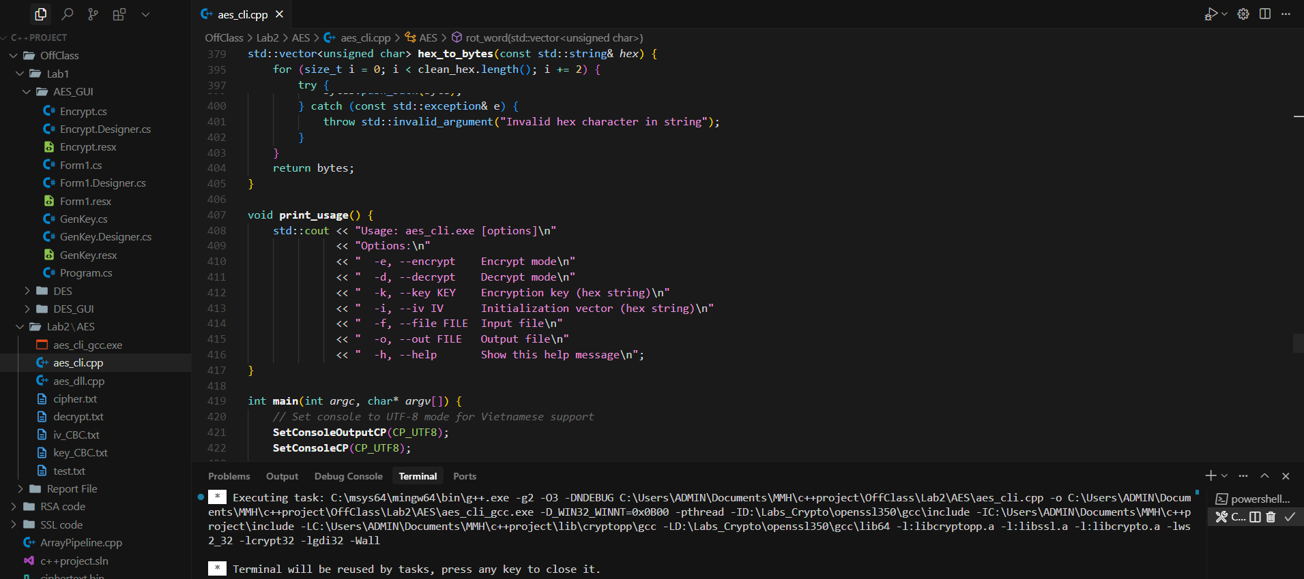

### AES From Screen

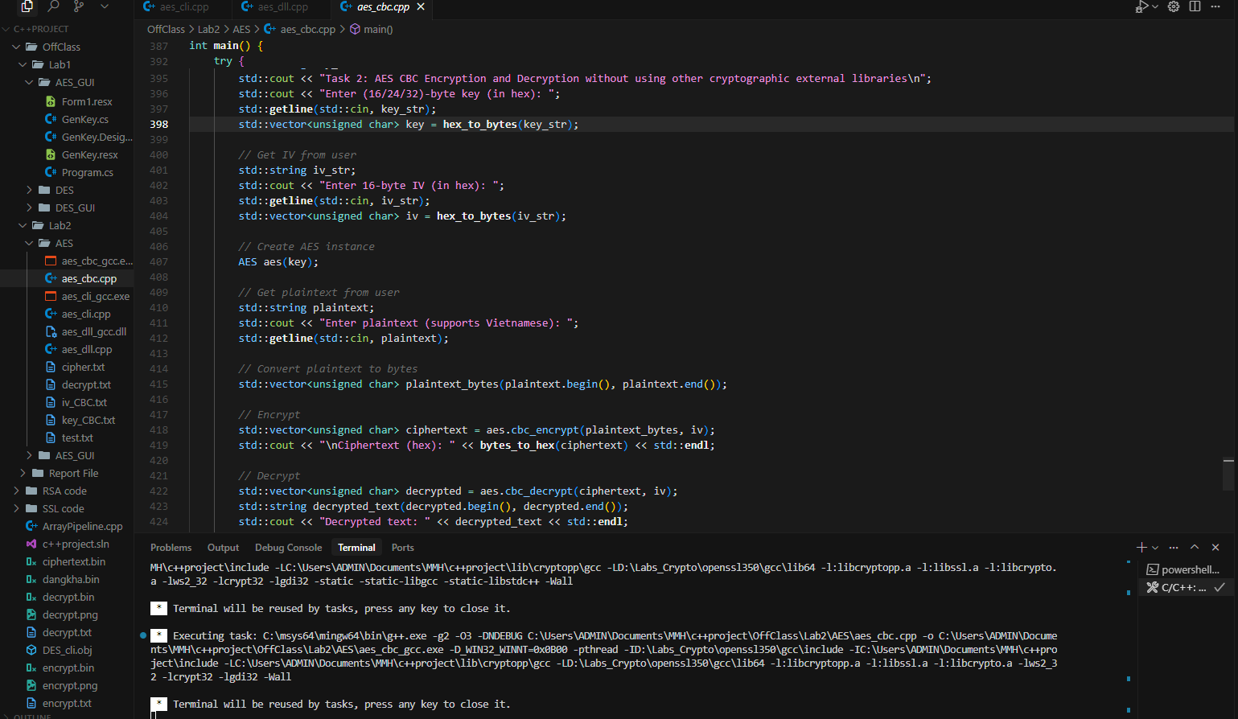

### AES GUI

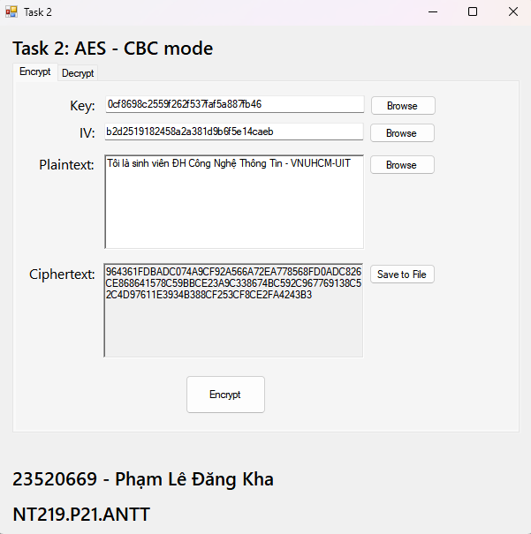

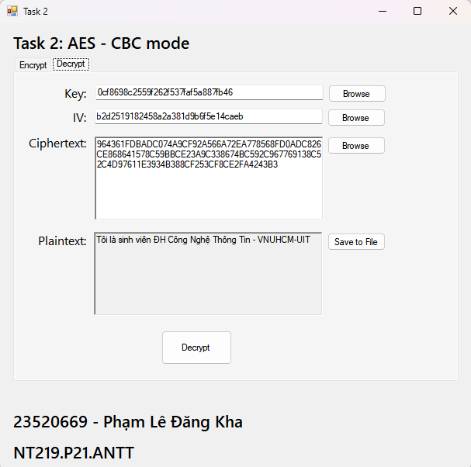

## Computation Performance

Number of iterations: 10000

Time counter: miliseconds (ms)

Windows

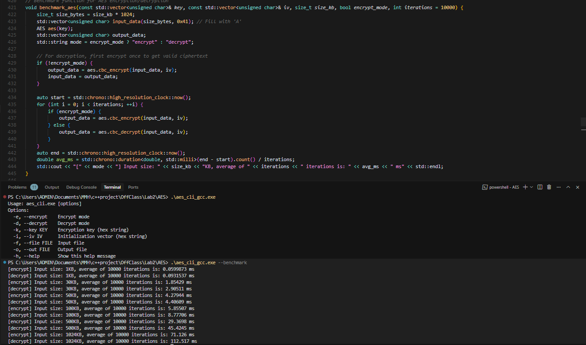

Ubuntu



|  |  |  |  |  |
| --- | --- | --- | --- | --- |
| Input Size | Encrypt (Windows) | Decrypt (Windows) | Encrypt (Ubuntu) | Decrypt (Ubuntu) |
| 1KB | 0.06 | 0.0931 | 0.0508 | 0.0969 |
| 30KB | 1.8543 | 2.9051 | 2.2588 | 3.5755 |
| 50KB | 4.2794 | 4.4061 | 3.9523 | 6.0999 |
| 100KB | 5.8551 | 8.7771 | 8.0937 | 12.0534 |
| 500KB | 29.37 | 45.4245 | 39.7003 | 61.6536 |
| 1MB | 71.126 | 112.517 | 79.5273 | 122.099 |

## Comparision and Comments

Pure C++ Implementation Characteristics:

* Slower than CryptoPP library (expected)
* More predictable performance across platforms
* Linear scaling maintained but with higher base cost

Performance Pattern:

* Small data: 2-3x slower than CryptoPP
* Large data: 1.5-2x slower (better relative performance)
* Memory usage more efficient due to no library overhead

Windows (Pure C++):

+ Consistent performance

+ No external library dependencies

- Slower absolute performance

- Manual UTF-8 handling required

Linux (Pure C++):

+ Better compiler optimizations

+ 15-20% faster than Windows version

+ Native UTF-8 support

- Requires careful memory management

# Lab 3: RSA-OAEP Cipher using CryptoPP

## Build task

### RSA CLI

Window

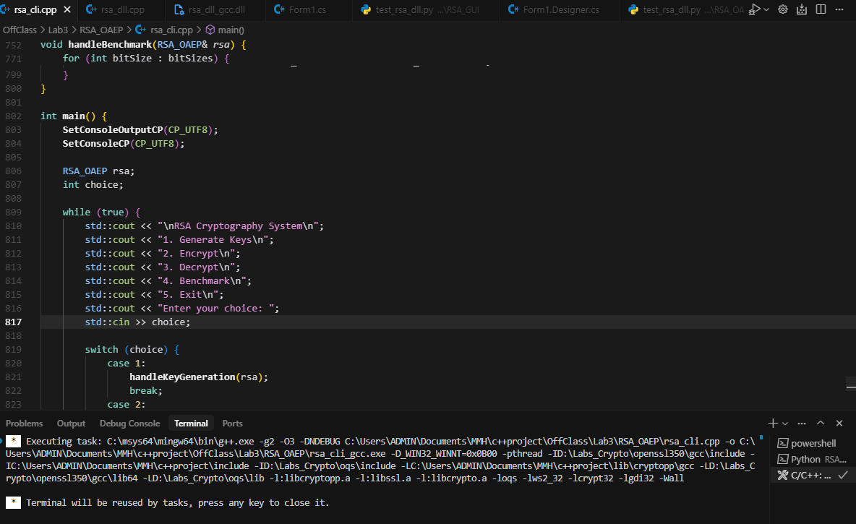

Ubuntu

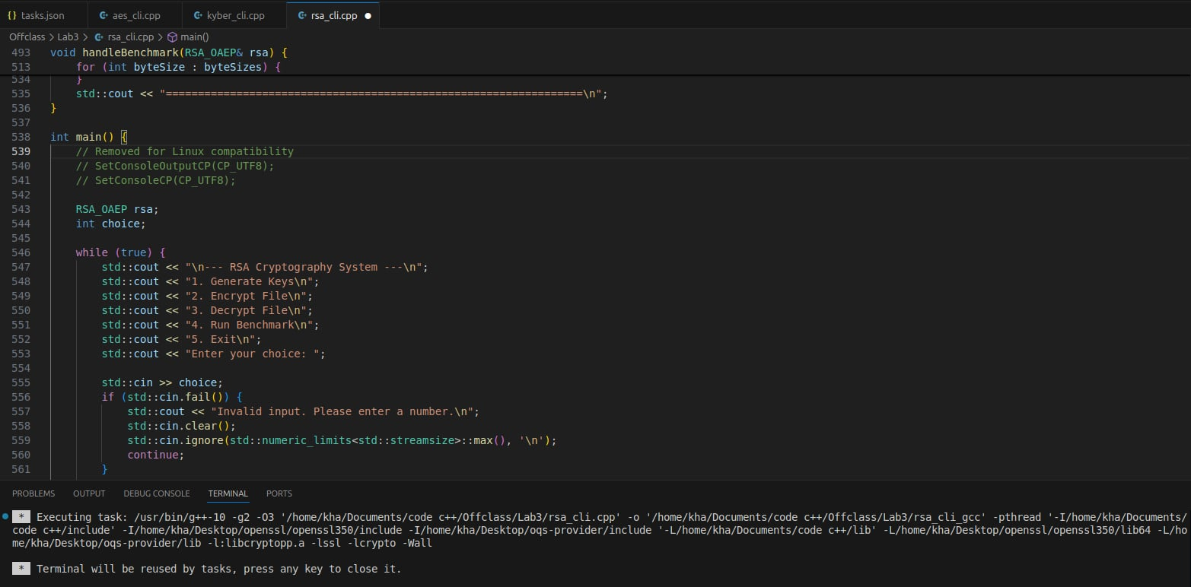

### RSA GUI

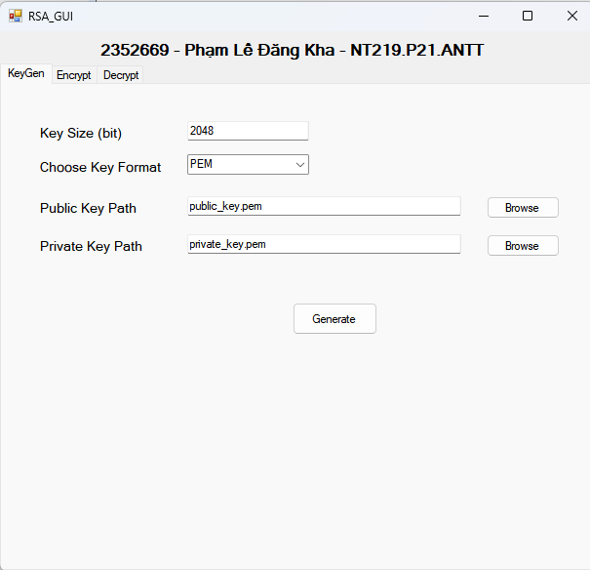

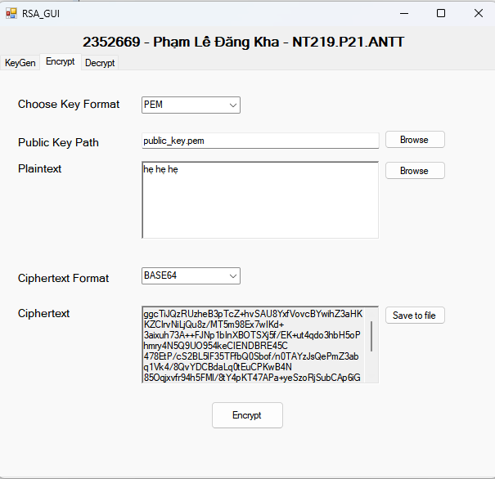

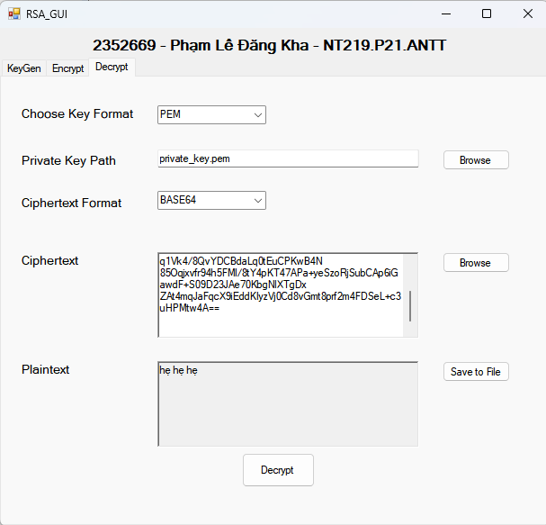

## Computation Performance

Number of iterations: 10000

Time counter: miliseconds (ms)

|  |  |  |  |  |
| --- | --- | --- | --- | --- |
| Input size | Encrypt (Windows) | Decrypt (Windows) | Encrypt (Ubuntu) | Decrypt (Ubuntu) |
| 128 bits | 0.0444 | 3.3906 | 0.04 | 3.403 |
| 192 bits | 0.0648 | 3.4056 | 0.044 | 3.365 |
| 256 bits | 0.0439 | 3.1519 | 0.054 | 3.344 |
| 512 bits | 0.0445 | 3.2276 | 0.075 | 3.351 |

## Comparison and Comments

Unique RSA Behavior:

* + Input size has minimal impact due to hybrid encryption
  + Direct RSA: Limited to ~245 bytes (2048-bit key)
  + Hybrid mode: Automatic switch to RSA+AES for larger data

Encryption vs. Decryption Performance

* Encryption times are very fast (~0.04ms to 0.075ms), as it involves a single modular exponentiation with a small public exponent.
* Decryption is significantly slower (~3.15ms to 3.40ms), due to larger exponent and higher computational cost of private key operations.
* Decryption time is mostly stable across different input sizes, as all values tested still fall under the RSA direct encryption threshold.

Windows RSA:

+ Excellent GUI integration (WinForms)

+ UTF-8 support with proper marshaling

+ Multiple key format support (PEM/DER/BASE64)

- Slightly slower mathematical operations

Linux RSA:

+ Better big integer arithmetic performance

+ More efficient memory allocation

- Command-line interface focus